Exp. No: 3 Determination and plotting of Force of attraction between two electric Charges and two parallel conductors separated by varying distance.
Aim:
To Determination and plotting of Force of attraction between two electric Charges and two parallel conductors separated by varying distance between them using SCILAB.

Software required:
•SCILAB version 6.0.1

Program:
clc;
clear;
charge_1 = input("Enter the charge_1 value=");
charge_2 = input("Enter the charge_2 value=");
radius = input("Enter the radius value=");
current_1 = input("Enter the current_1 value=");
current_2 = input("Enter the current_2 value=");
l = input("Enter the length value=");
d = input("Enter the d value=");
mu = 4*3.14*10^-7;
efcilon=8.854*10^-12;
pi=3.14;
F=(charge_1 * charge_2)/4*pi*efcilon*radius^2;
f=((mu*current_1*current_2*l)/2*pi*d)
disp("THE FORCE BETWEEN TWO ELECTRIC CHARGES", [F]);
disp("THE FORCE BETWEEN TWO PARALLEL CONDUCTORS", [f]);
x = linspace(0, 10, 50);
y = F * exp(-0.1 * x);
z = f * exp(-0.1 * x);
figure();
subplot(2, 2, 1);
plot2d3(x,y);
xlabel("R");
ylabel("Force");
title('FORCE BETWEEN TWO ELECTRIC CHARGES');
subplot(2, 2, 2);
plot2d3(x,z);
xlabel("D");
ylabel("Force");
title('FORCE BETWEEN TWO PARALLEL CONDUCTORS');

Output:-

Enter the charge_1 value=1
Enter the charge_2 value=2
Enter the radius value=3*10^2
Enter the current_1 value=3
Enter the current_2 value=4
Enter the length value=5
Enter the d value=3
"THE FORCE BETWEEN TWO ELECTRIC CHARGES"
0.0000013
"THE FORCE BETWEEN TWO PARALLEL CONDUCTORS"
0.0003549
Case 1 :
Given two point charges q1=2×10^−6 and q2=3×10^−6 C, calculate and plot the force of attraction between them as a function of distance, ranging from 0.1 m to 10 m. Explain how the force changes with the distance between the charges.
Code:
// Parameters for two point charges
ke = 8.99e9; // Coulomb's constant (N*m^2/C^2)
q1 = 2e-6; // Charge 1 (Coulombs)
q2 = 3e-6; // Charge 2 (Coulombs)
r = linspace(0.1, 10, 100); // Distance between charges (m)

// Calculate force as a function of distance
F = ke * abs(q1 * q2) ./ r.^2;

// Plotting the force vs distance
plot(r, F, "r");
xlabel("Distance (m)");
ylabel("Force (N)"); // Parameters for two point charges
ke = 8.99e9; // Coulomb's constant (N*m^2/C^2)
q1 = 2e-6; // Charge 1 (Coulombs)
q2 = 3e-6; // Charge 2 (Coulombs)
r = linspace(0.1, 10, 100); // Distance between charges (m)

// Calculate force as a function of distance
F = ke * abs(q1 * q2) ./ r.^2;

// Plotting the force vs distance
plot(r, F, "r");
xlabel("Distance (m)");
ylabel("Force (N)");
title("Force of Attraction Between Two Point Charges");

Output:
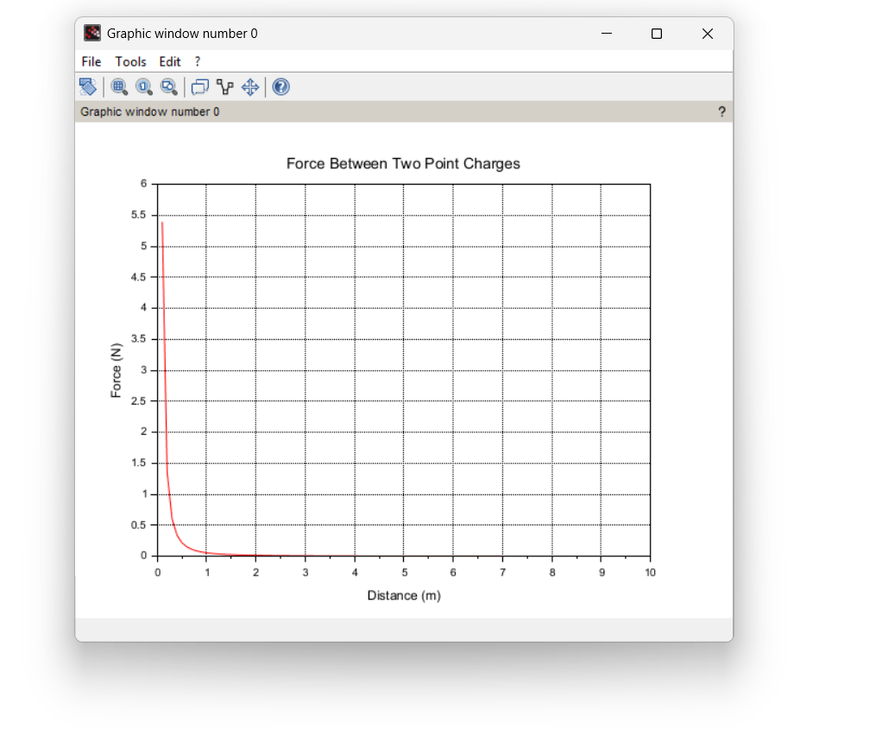

Case 2:
Given two point charges q1=5×10^−6 C and q2=2×10^−6 , calculate and plot the force of attraction between them as the distance varies from 0.5 m to 5 m. Discuss how the force behaves with the varying distance and charge magnitudes.
Code:
// Parameters for two point charges
clc;
ke = 8.99e9; // Coulomb's constant (N*m^2/C^2)
q1 = 5e-6; // Charge 1 (Coulombs)
q2 = 2e-6; // Charge 2 (Coulombs)
r = linspace(0.5, 5, 100); // Distance between charges (m)

// Calculate force as a function of distance
F = ke * abs(q1 * q2) ./ r.^2;

// Plotting the force vs distance
plot(r, F, "b");
xlabel("Distance (m)");
ylabel("Force (N)");
title("Force of Attraction Between Two Point Charges (Different Magnitudes)")

Output:
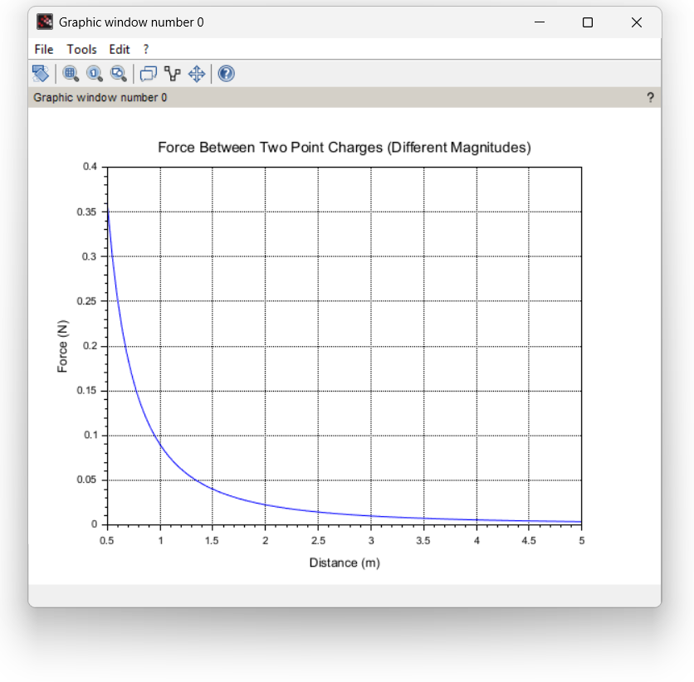
Case 3:
Two parallel conductors are separated by a distance d. The first conductor carries a current of I1=5 A, and the second conductor carries a current of I2=10 A. Calculate and plot the force per unit length between the conductors for varying distances from 0.1 m to 10 m. Explain how the force changes with the distance between the conductors
Code:
// Parameters for two parallel conductors
clc;
mu0 = 4 * %pi * 1e-7; // Permeability of free space (N/A^2)
I1 = 5; // Current in conductor 1 (Amperes)
I2 = 10; // Current in conductor 2 (Amperes)
d = linspace(0.1, 10, 100); // Distance between conductors (m)

// Calculate force per unit length as a function of distance
F_per_length = (mu0 * I1 * I2) ./ (2 * %pi * d);

// Plotting the force per unit length vs distance
plot(d, F_per_length, "g");
xlabel("Distance (m)");
ylabel("Force per Unit Length (N/m)");
title("Force Between Two Parallel Conductors (Different Currents)");

Output:
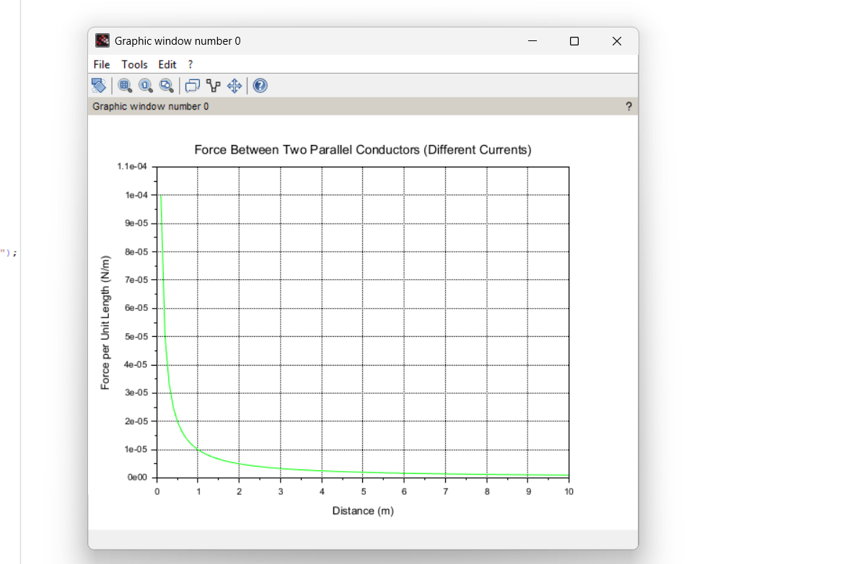

Case 4:
Given two parallel conductors carrying currents of 3 A, calculate and plot the force per unit length between the conductors for varying distances between 0.1 m to 2 m. Discuss the relationship between the distance and the force between the conductors.
Code:
// Parameters for two parallel conductors
clc;
mu0 = 4 * %pi * 1e-7; // Permeability of free space (N/A^2)
I1 = 3; // Current in conductor 1 (Amperes)
I2 = 3; // Current in conductor 2 (Amperes)
d = linspace(0.1, 2, 100); // Distance between conductors (m)

// Calculate force per unit length as a function of distance
F_per_length = (mu0 * I1 * I2) ./ (2 * %pi * d);

// Plotting the force per unit length vs distance
plot(d, F_per_length, "m");
xlabel("Distance (m)");
ylabel("Force per Unit Length (N/m)");
title("Force Between Two Parallel Conductors (Same Current)");

Output:
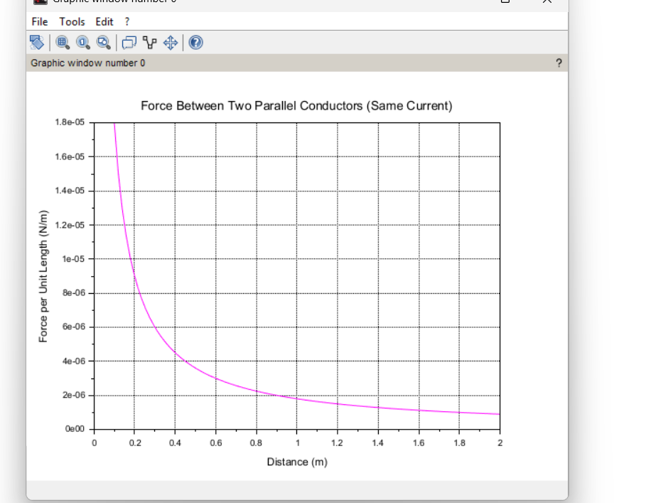

Result :Thus the program was verified for the force of attraction or repulsion acting along a straight line between two electric charges is directly proportional to the product of the charges and inversely to the square of the distance between them using SCILAB was successfully.

